


education RESOURCES

Executive Director Jim Gilhooly

St.Hilary’s Primary and Nursery Class - Head Teacher Mrs. P. Stewart

December 2014 Newsletter

Summary of events during November
Mrs Magee undertook a 5 week programme of Forest School activities with 20 children from P4 – P6 and I would like to thank our parent helpers Mrs Pieliochowska and Mrs Toner who escorted the children on their weekly adventures in challenging weather conditions. The programme which we will endeavour to run each year is designed to build confidence and resilience in children. Congratulations and thanks also to Mrs Magee on her completion of the Forest Schools Training Award.

Parents’ Night
Thank you to everyone who completed a questionnaire after parents’ night. The feedback results of the survey are on display in the corridor leading to the gym, please feel free to add any additional remarks on the post it notes available.

St Andrews Day We held a small gathering at the end of Friday to celebrate our heritage and culture, the children as always excelled in their performances and we ended with an impromptu recital of The Wee Kirkcudbright Centipede by P4 – P7 .
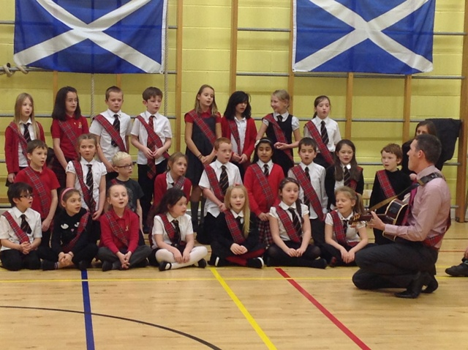
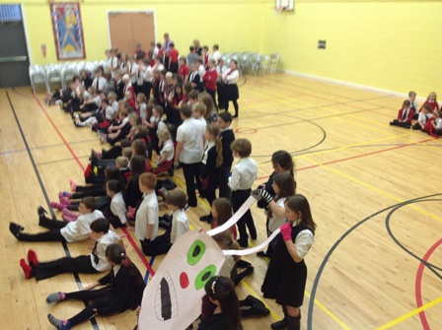
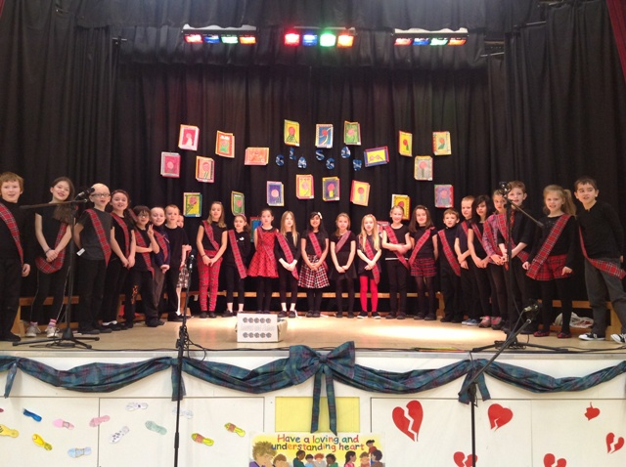

Primary 7 enjoyed a science lesson from our secondary
colleagues at St Andrew’s and St Bride’s High School;
they also paid their first visit to the High School for a follow up lesson.
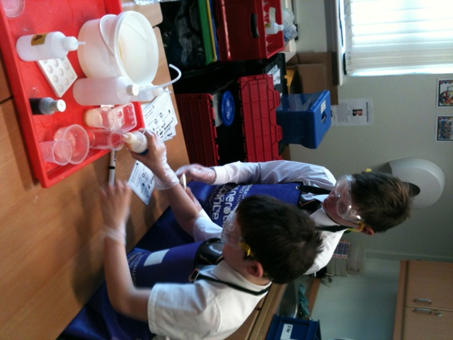
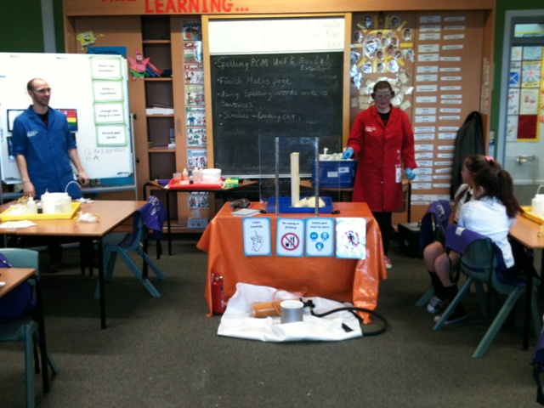

Primary 6 Pupils will be invited next Sunday to attend St Leonard’s 10am Mass along with their parents and the P6 pupils of St Leonard’s primary to enrol for their Pope Francis Faith Award.

Our senior pupils have represented the school this month in Athletics / Football and Netball. During this week P6 & P7 will attend a handball tournament at the John Wright Sports Centre.

Primary 5 have been very enterprising this month as they endeavour to subsidise the trip on Thursday to New Lanark, they prepared and sold cakes raising £66 towards their outing, £146.25 further subsidised by the National Trust and the school reducing the cost to £4.00 per child.

Primary 4 held their award ceremony on Friday morning and impressed their large audience with their message of empathy for others, along with their singing and dancing it was excellent.

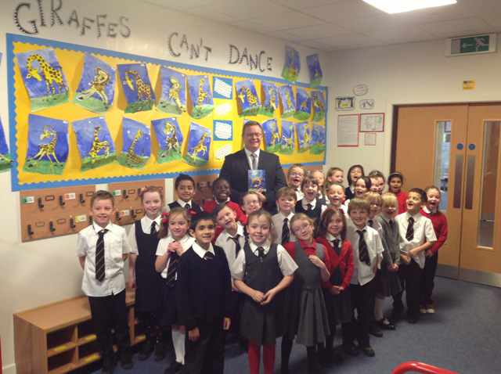
Primary 3 had a visit during book week last week from SLC’s Graeme Barclay, Instrumental Music Co- ordinator who read his favourite children’s book to the class as part of a council wide initiative for senior managers to read to as wide an audience as possible during book week.

Primary 2/3 have enjoyed P7 pupils visiting their class to read this year’s book bug selection, the senior pupils have been involved in assessing the latest novels in the Shared Reading Programme. As one of 10 schools in south Lanarkshire our P7 pupils have been fortunate to engage in this project. They were further selected to receive input from a drama specialist to enhance their reading skills, one of only 3 schools selected. The experience will equip our senior pupils with a lifelong skill of enriching reading both for themselves and others.

Primary 1 Pupils have been issued with the Book Bug Pack and I hope each family will enjoy the excellent reading materials available for themselves. On the continuing subject of books, thank you to everyone who purchased books at the recent Book Fayre held on Parents’ Night the school benefit from the commission in the form of books and this year the total was £519.34. Thank You.

Our choir sang at the Town Centre today, which will be followed by another recital at the local library on 16th December. Thank you to Mrs Herd and Mrs McCabe who are currently instructing the choir as well as directing and preparing for the forthcoming Christmas concert “The Stars Come Out for Christmas.” It promises to be quite something.

The dates for our concerts are as follows
December 9th | Nursery 10am | Nursery 2pm
December 11th | Nativity P1 – 7 | At 1.15pm
December 12th | Nativity P1 – 7 | At 1.15pm

The dress rehearsal will be Wednesday 10th December and I would be obliged if children’s punctuality and attendance are good on these dates to support their fellow pupils.

Parking
Staff members will park at the rear of the gym hall for the concerts on the 11th and 12th to make available as many spaces as possible. Please be safe and considerate in your parking.

Advent
Today we held our first Advent Service and children are reminded to be considerate of those less fortunate than themselves. Our charitable tree appeal this year will take the form of SCIAF real gifts where the usual weekly MISSIO donations will be diverted to SCIAF.

There will also be a hamper raffle during this session and each class will create their own themed hamper – small donations for the hampers will be most welcome. (Tickets cost 20p or £1 for a strip.) The draw will take place at the Tea and Coffee session following the service on19th December. This final Advent Service will be at 9.15 am parents, friends and family most welcome.
A copy of this newsletter will be on our website with some photographs inserted let me know if you prefer the photos included.

P Stewart
Head Teacher
-----------------------------------------------------------------------------------------------------------------------------------------
I have received the December Newsletter.
Comments box:

Signature: Parent of:

